

UNIVERSIDAD DE LAS FUERZAS ARMADAS “ESPE”

AULESTIA HERMOSA ARIEL MATEO

Aguirre Almache, Gabriel Sebastian

Ango Alquinga, Johny Javier

Arias Campos, Marco Antonio

Barrera Taco, Kevin Alejandro

NRC: 3730

PROGRAMACIÓN ORIENTADA A OBJETOS

Requirements 0/10

Dentro de la carpeta clonada no se encontró el documento con la descripción del problema

The document with the description of the problem was not found inside the cloned folder

Use Case D 0/10

the use case diagram is missing

Class D 8 /10 (you need a vpp class Diagram)

(The company name is not listed)

Code 8,5 /10 (you need json code)

(too much cases in the code try to optimize )

(try to use well the if because in you code it doesn’t anything)

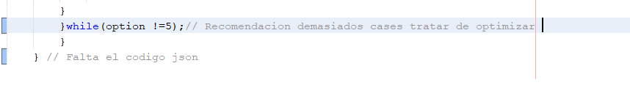

Executable 8,5 /10 (not Save in the file)

(not have a json file)

(Does not meet the requirements)

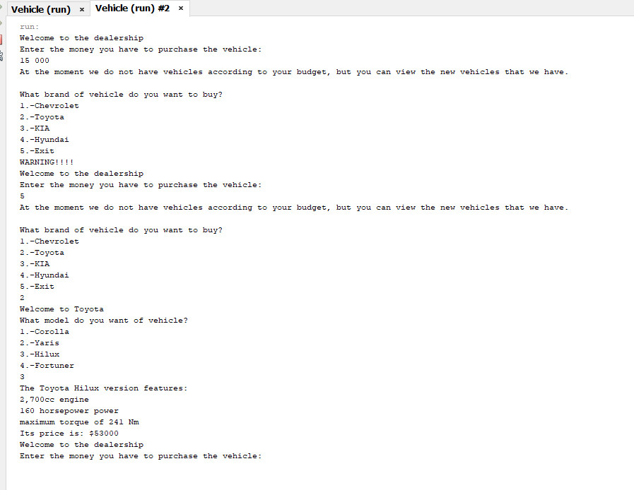

**Recomendation**

to use functions given in class for example Json.

At the time of programming, it is recommended that you show a correct interface, this is reflected in the menu with its correct organization of options. So that it is user-friendly. Within the code it is advisable to delete unnecessary lines, a common error is not to use